**EXPERIMENT 8**

**SAILOR BOAT DATABASE (DDL, DML, DQL, Subquery, Joins, Set operations)**

**Aim:**

* Create sailors, boats, and reserves.(foreign key)

**create schema sailors_;**

**create table sailors_(sid int, sname varchar(30),rating int, age real,primary key(sid));**

**create table boats_(bid int, bname varchar(30),color varchar(20),primary key (bid));**

**create table reserves_(sid int, bid int, day date,foreign key(sid) references sailors_(sid),foreign key(bid)references boats_(bid));**

**desc sailors_;**

**desc boats_;**

**desc reserves_;**

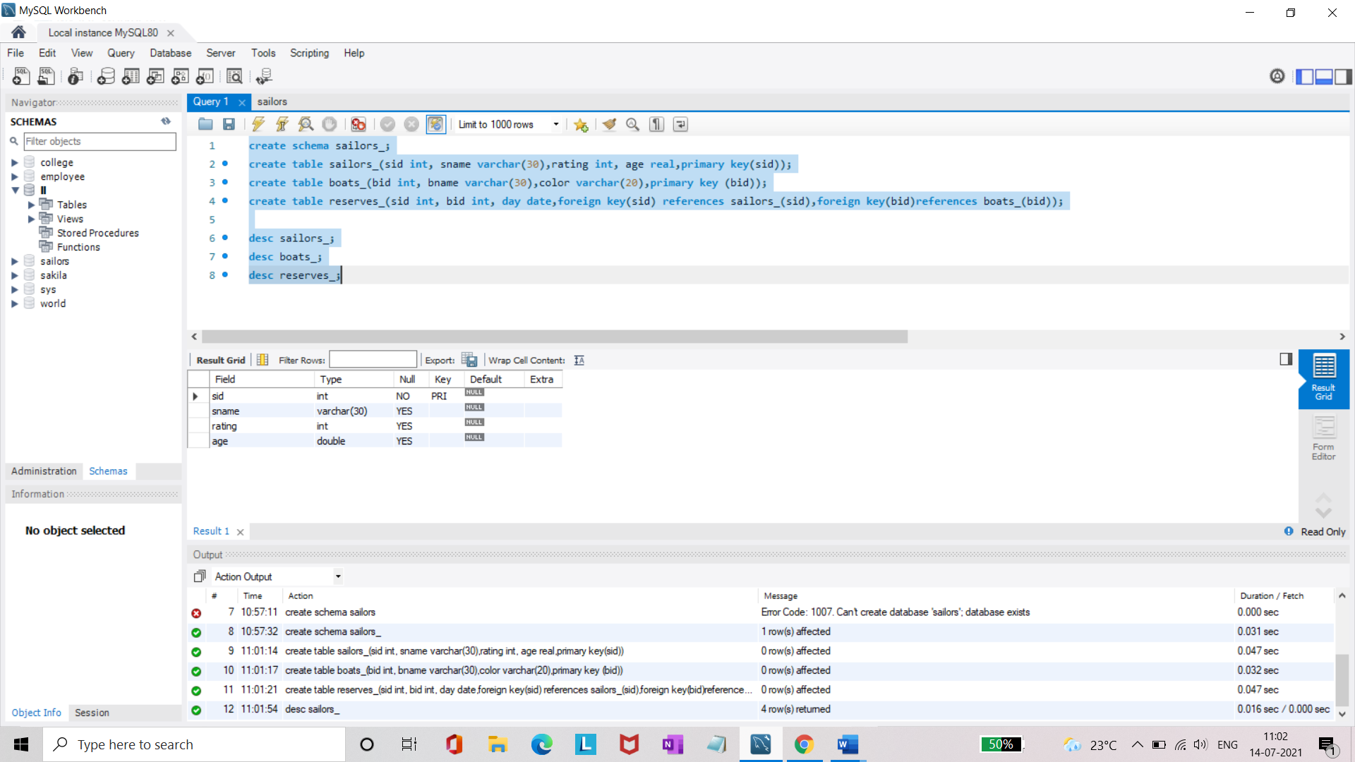

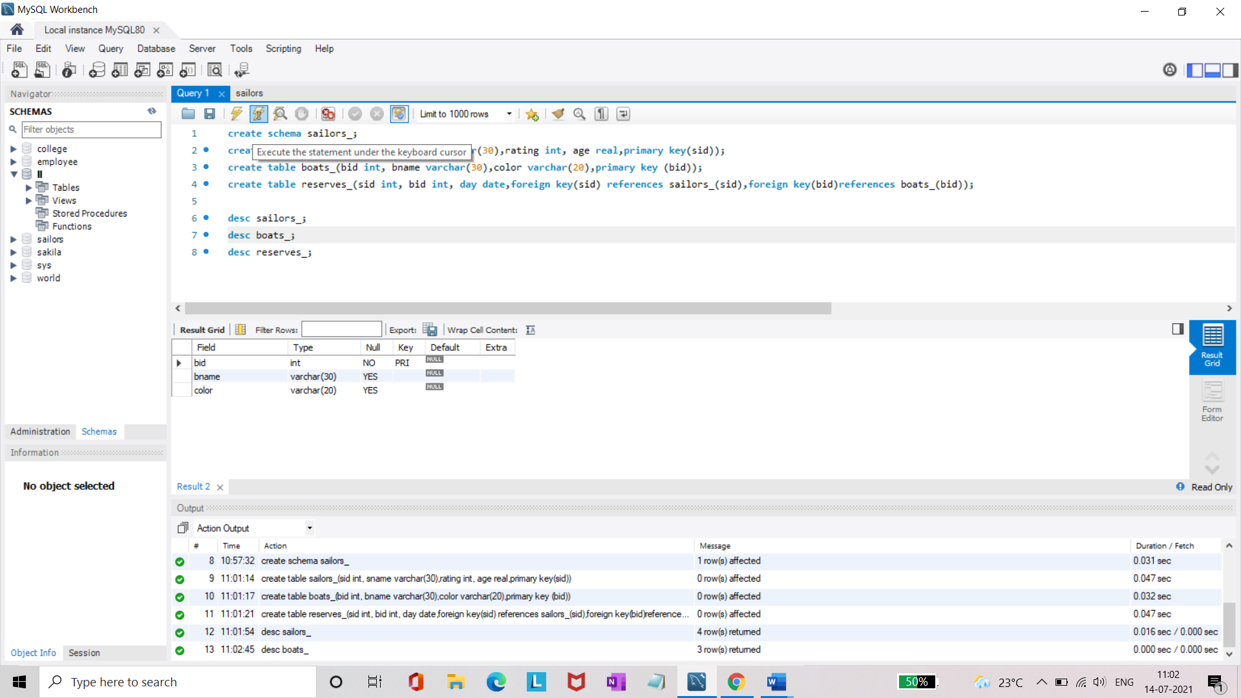

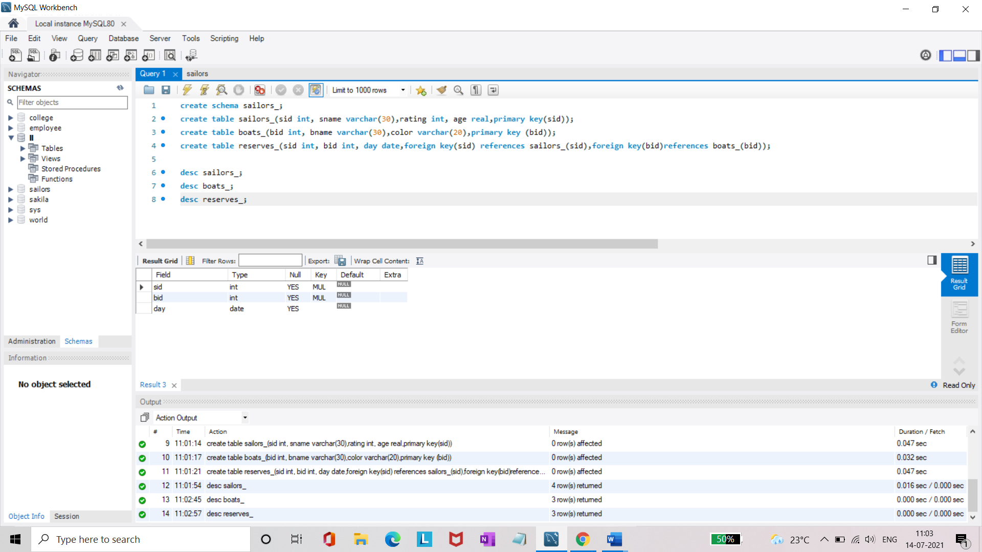

* Insert 5 values each table.
* Display all records.

**insert into sailors_ values(22,'Dustin',7,45.0),(29,'Brutus',1,33.0),(31,'Lubber',8,55.5),(32,'Andy',8,25.5),(58,'Rusty',10,35.0);**

**select * from sailors_;**

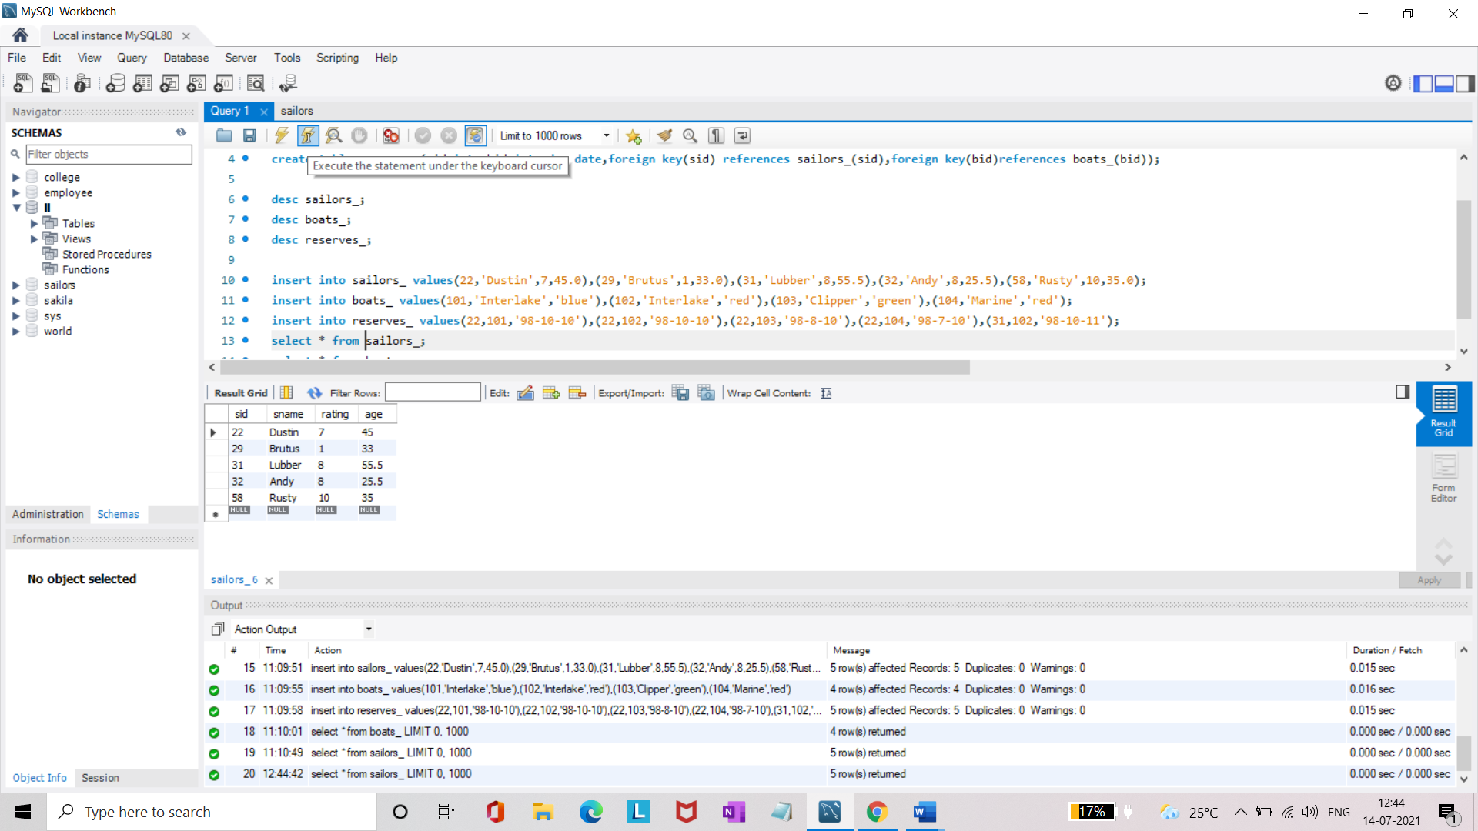

**insert into boats_ values(101,'Interlake','blue'),(102,'Interlake','red'),(103,'Clipper','green'),(104,'Marine','red');**

**select * from boats_;**

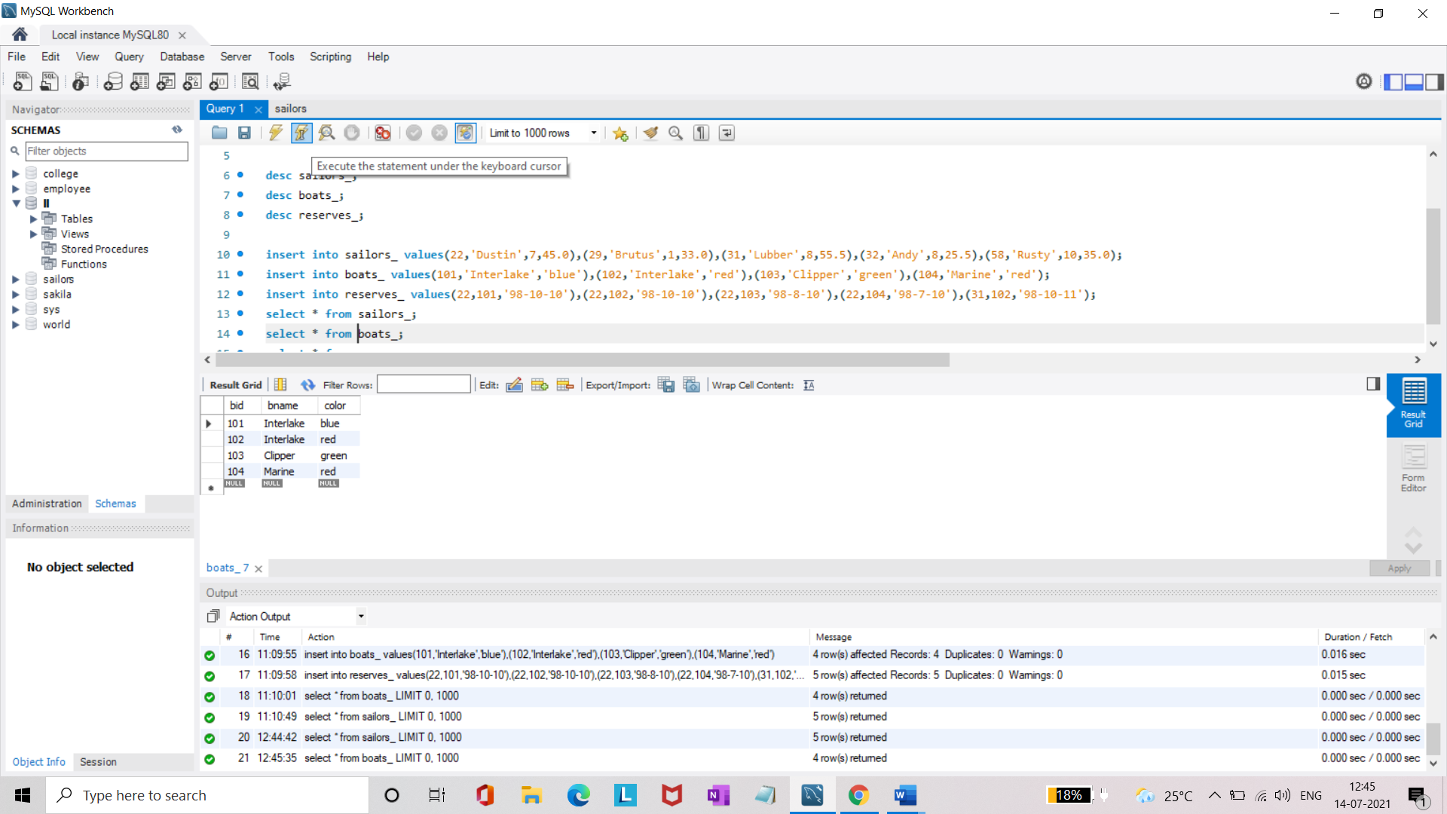

**insert into reserves_ values(22,101,'98-10-10'),(22,102,'98-10-10'),(22,103,'98-8-10'),(22,104,'98-7-10'),(31,102,'98-10-11');**

**select * from reserves_;**

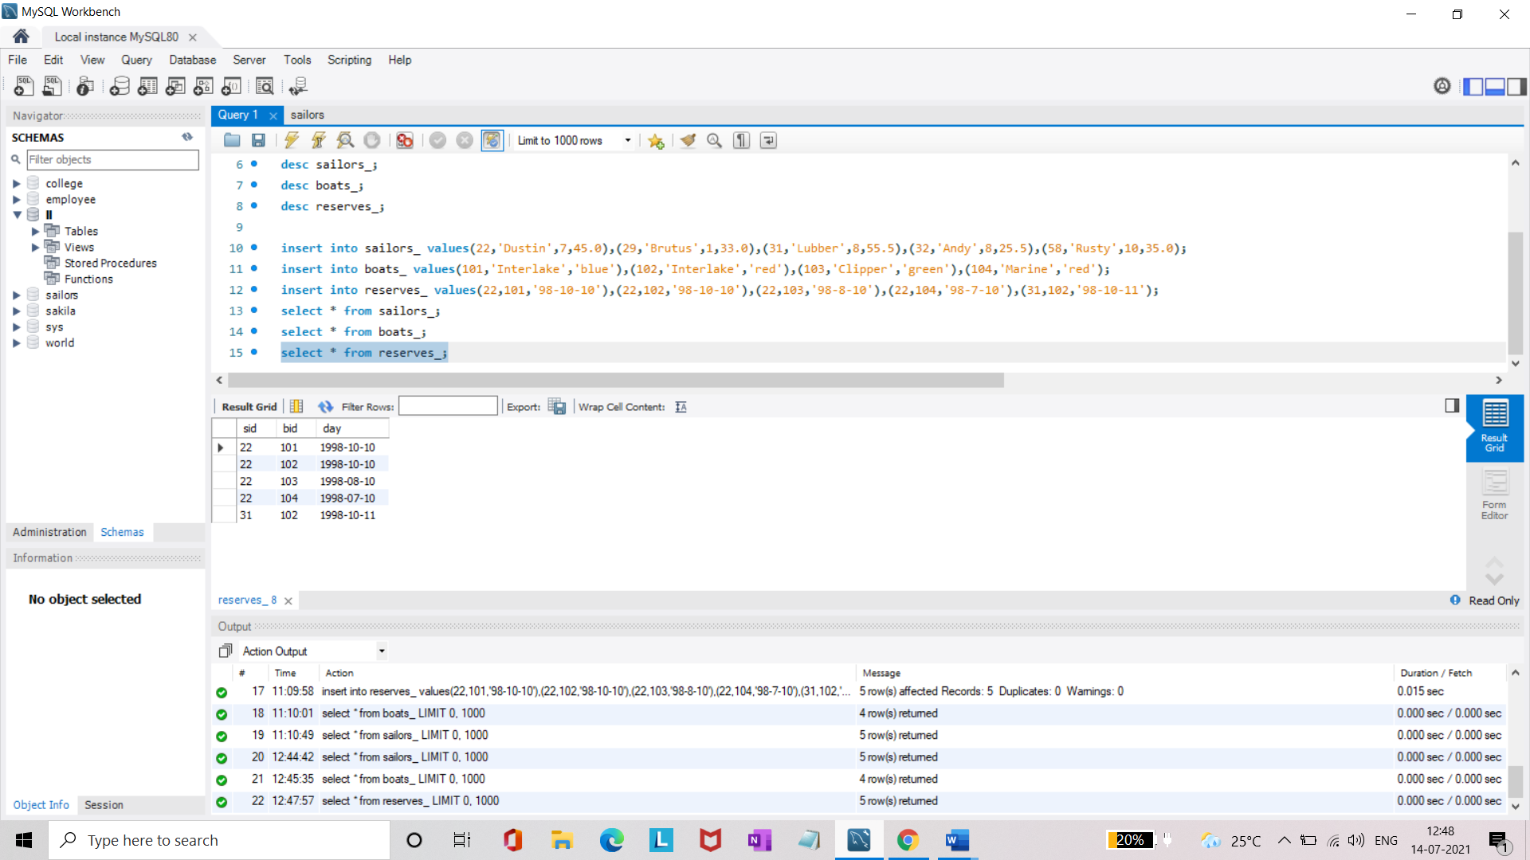

* Find the names and ages of all sailors.

**select sname,age from sailors_;**

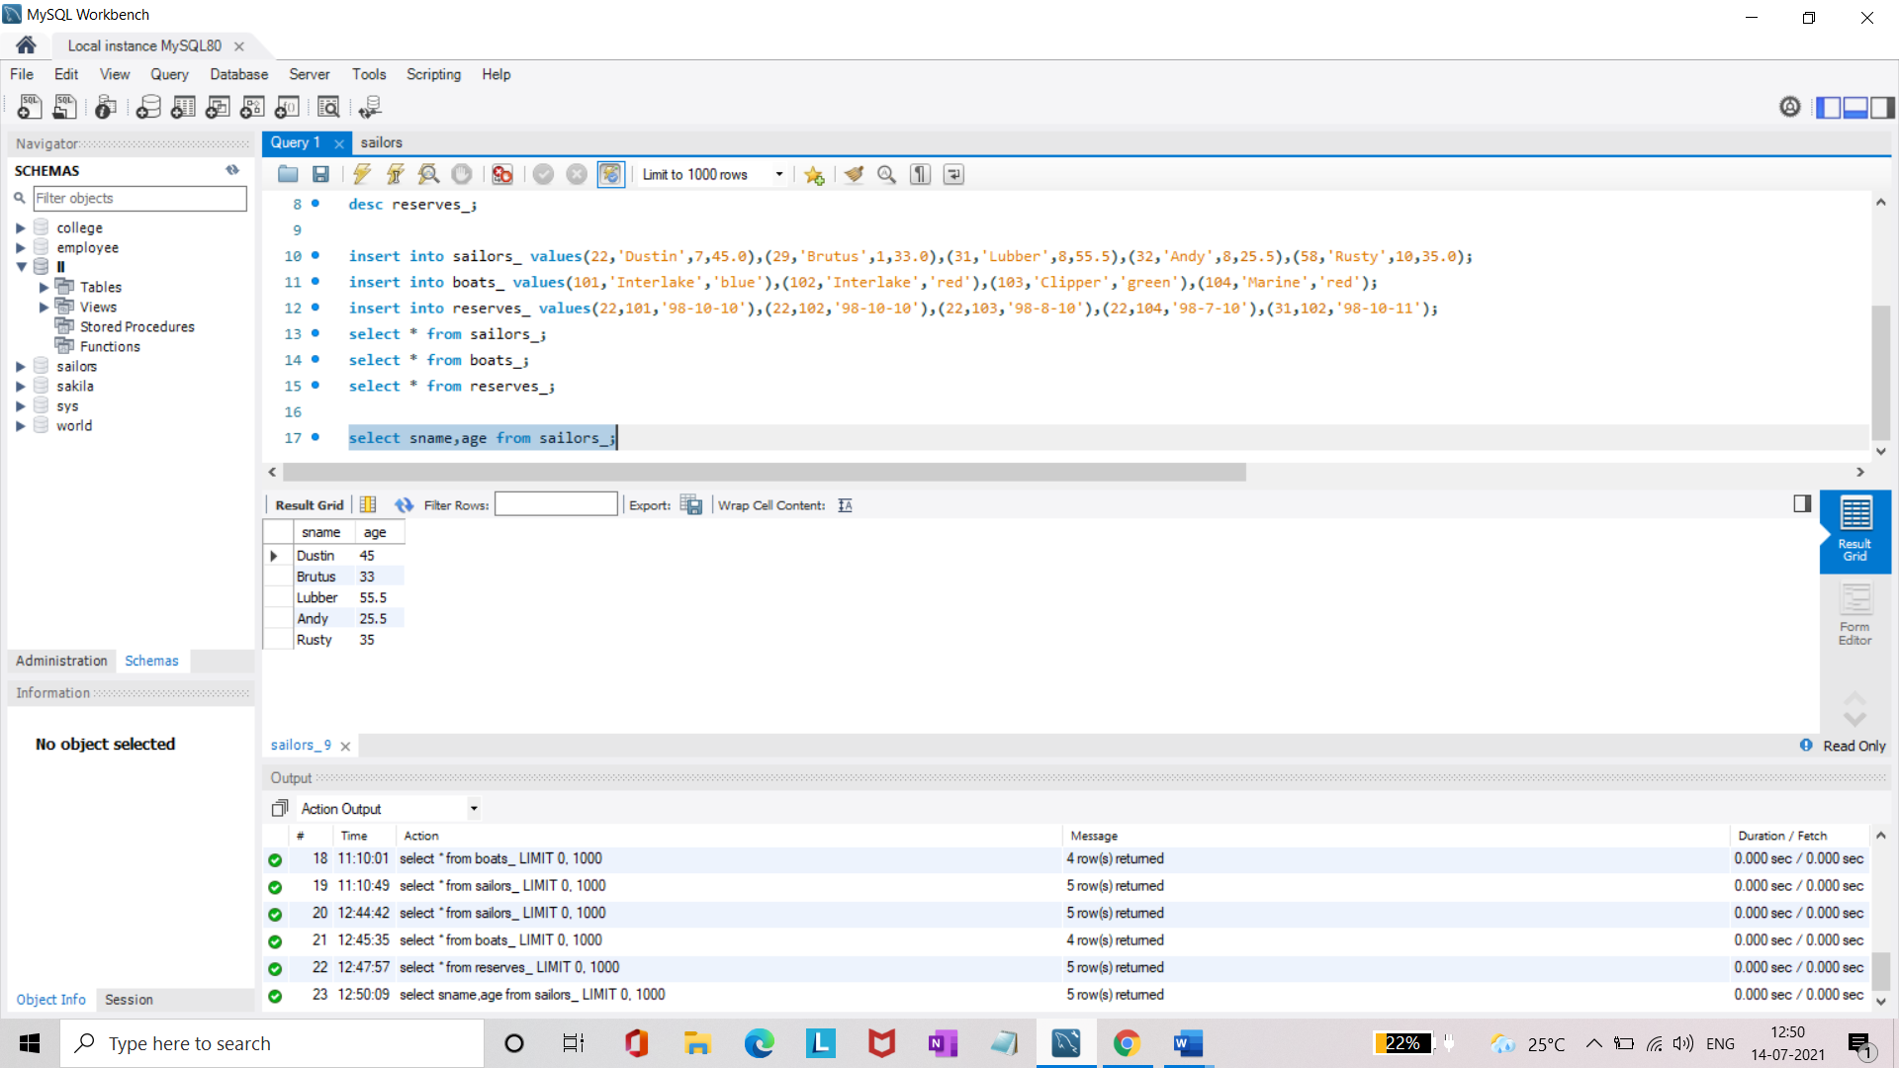

* Find all sailors with ratings above 8.

**select * from sailors_ where rating>8;**

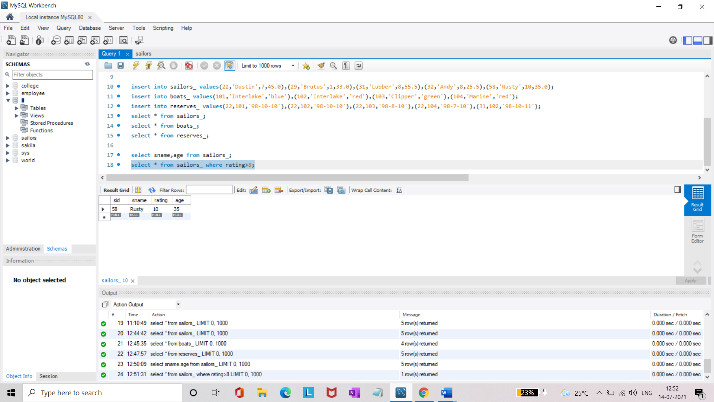

* Find sailors name with rating above 7 & age above 25.

**select sname from sailors_ where rating>7 and age>25;**

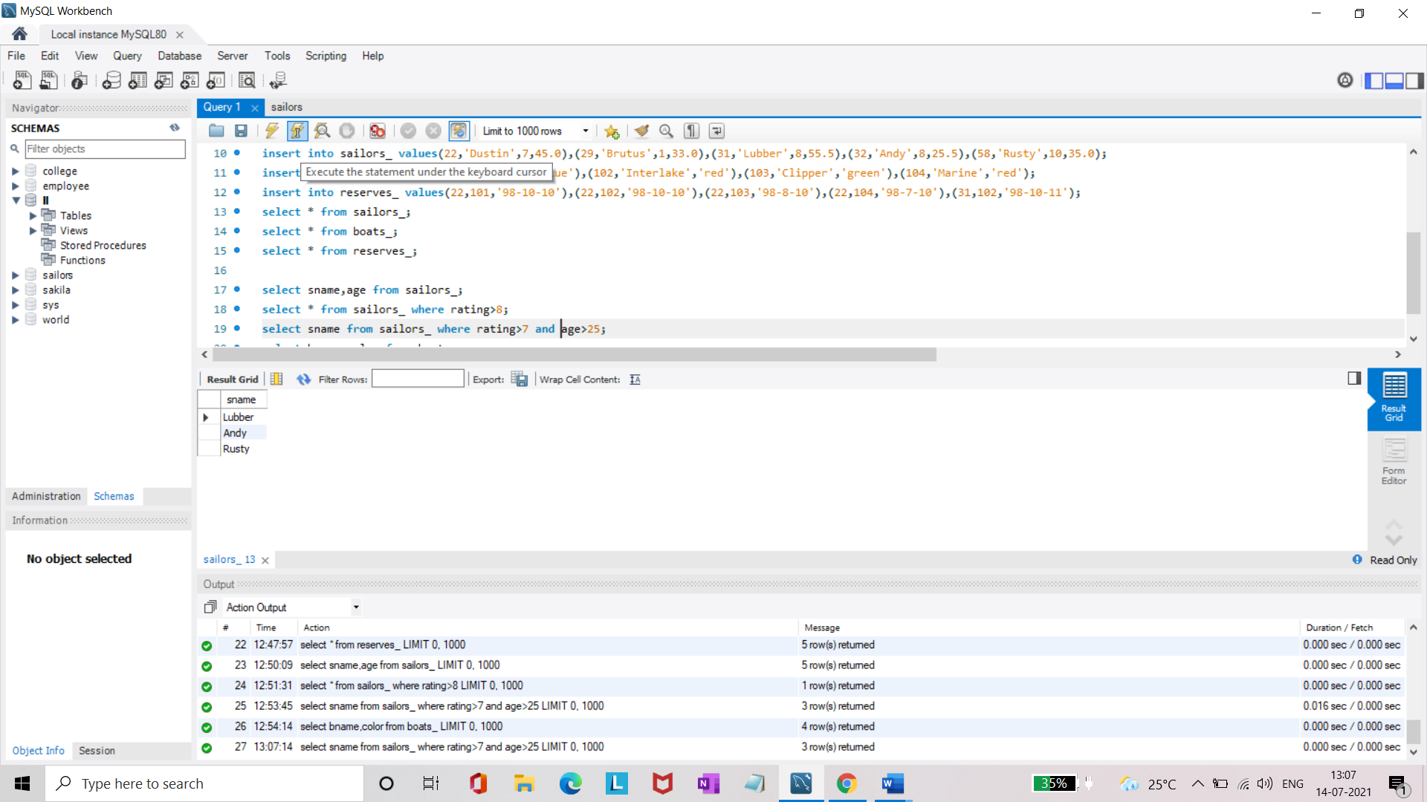

* Display all the names & colors of the boats.

**select bname,color from boats_;**

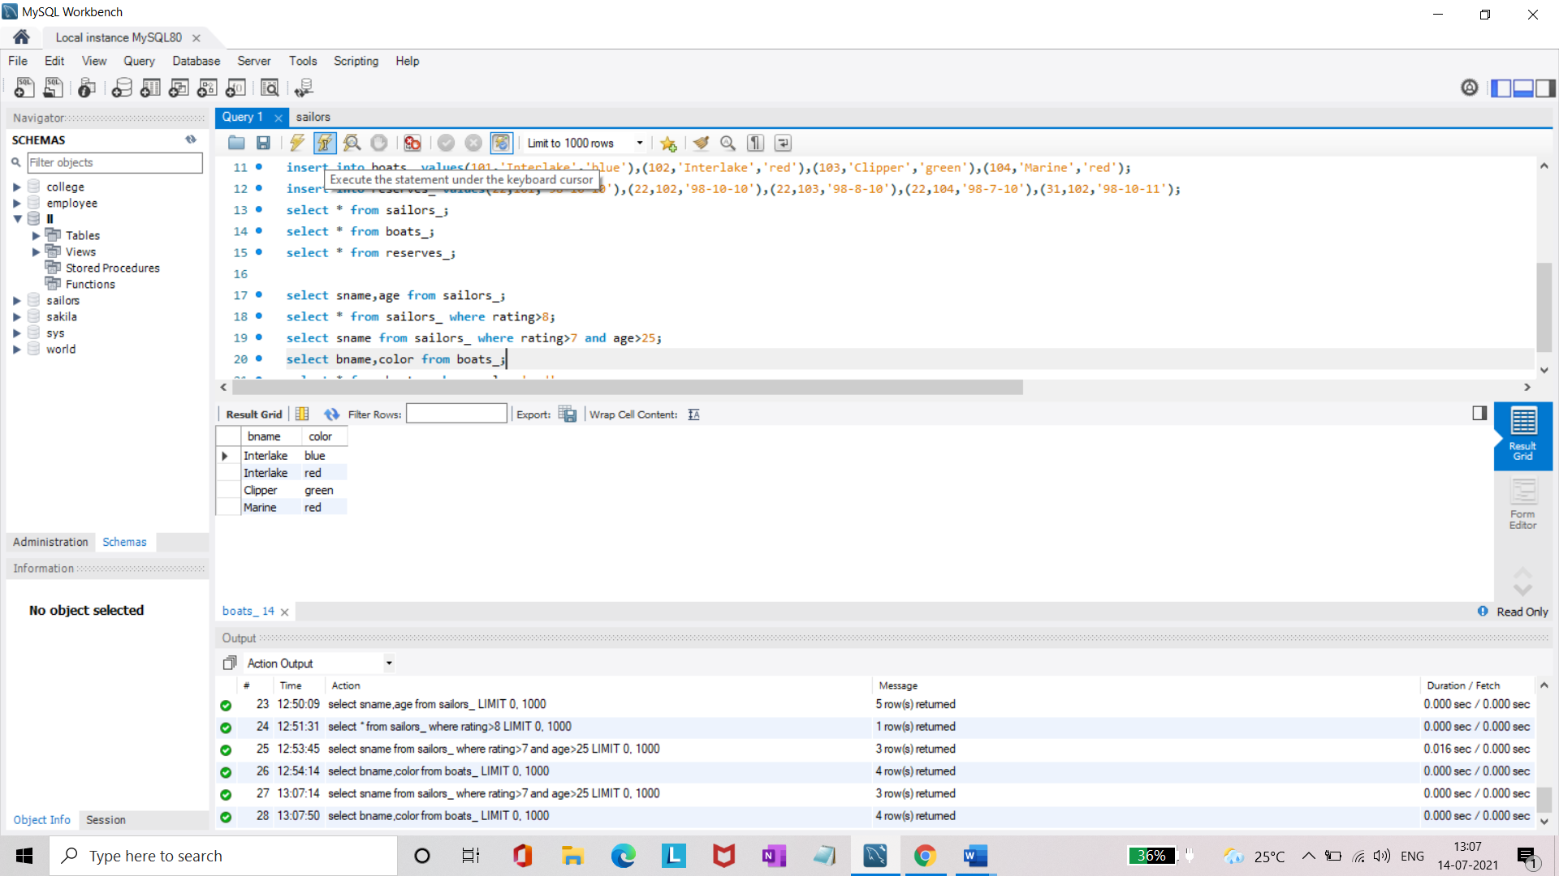

* Find all the boats with Red colors.

**select * from boats_ where color='red';**

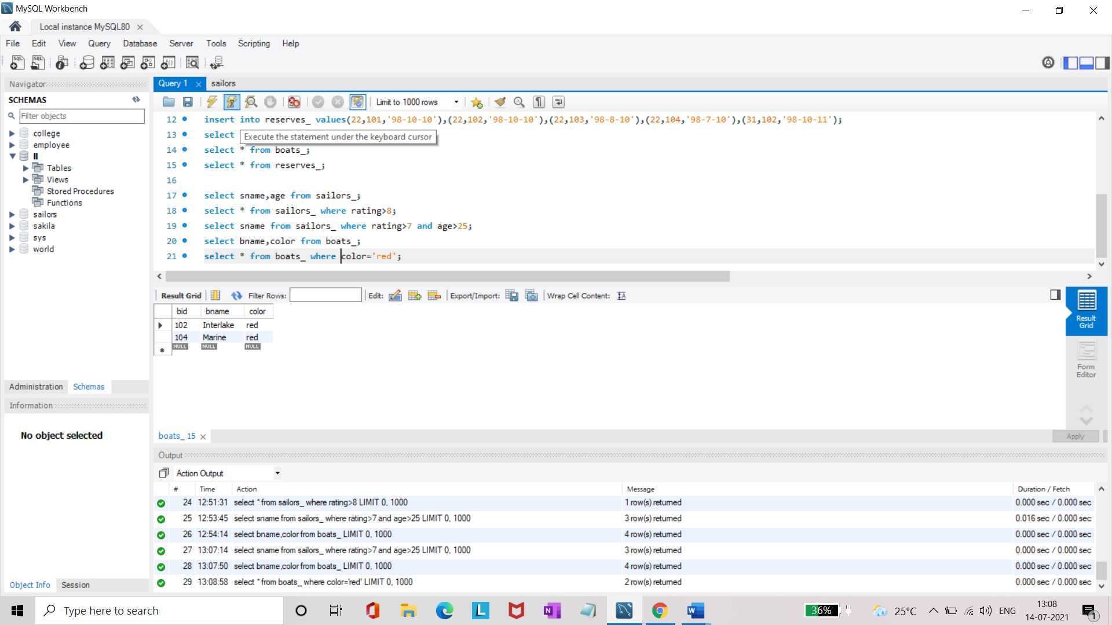

* Find the names of sailors' who have reserved boat number 103.

**select s.sname from sailors_ s, reserves_ r where s.sid=r.sid and r.bid=103;**

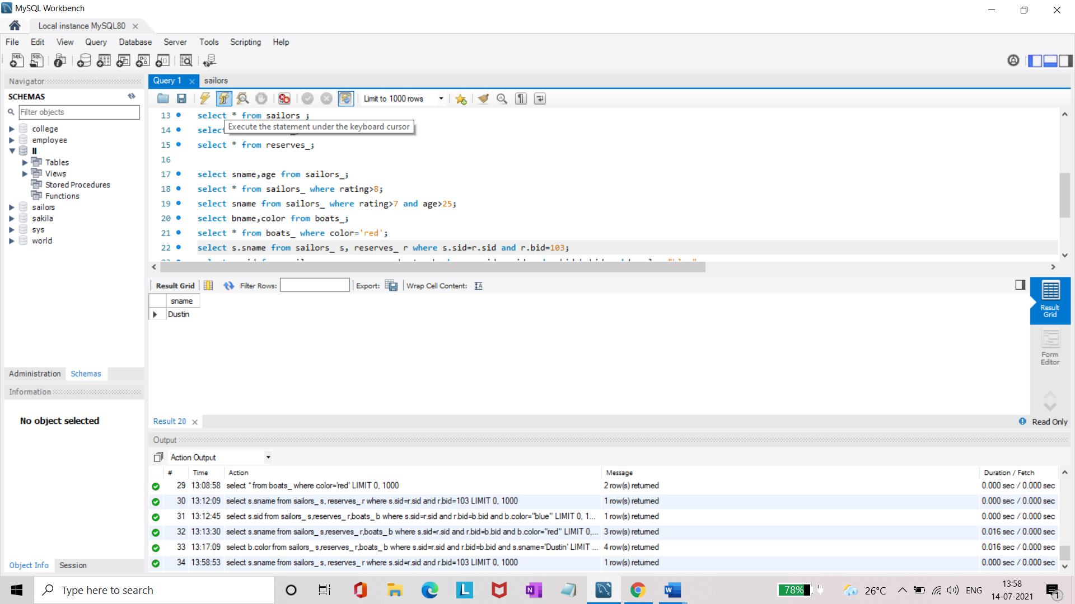

* Find the sids of sailors who have reserved blue boat

**select s.sid from sailors_ s,reserves_ r,boats_ b where s.sid=r.sid and r.bid=b.bid and b.color="blue";**

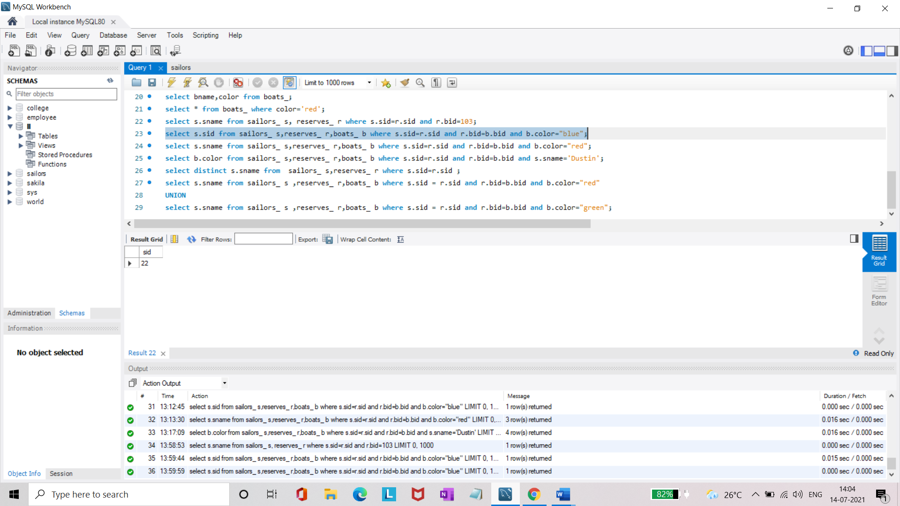

* Find the names of sailors' who have reserved Red boat.

**select s.sname from sailors_ s,reserves_ r,boats_ b where s.sid=r.sid and r.bid=b.bid and b.color="red";**

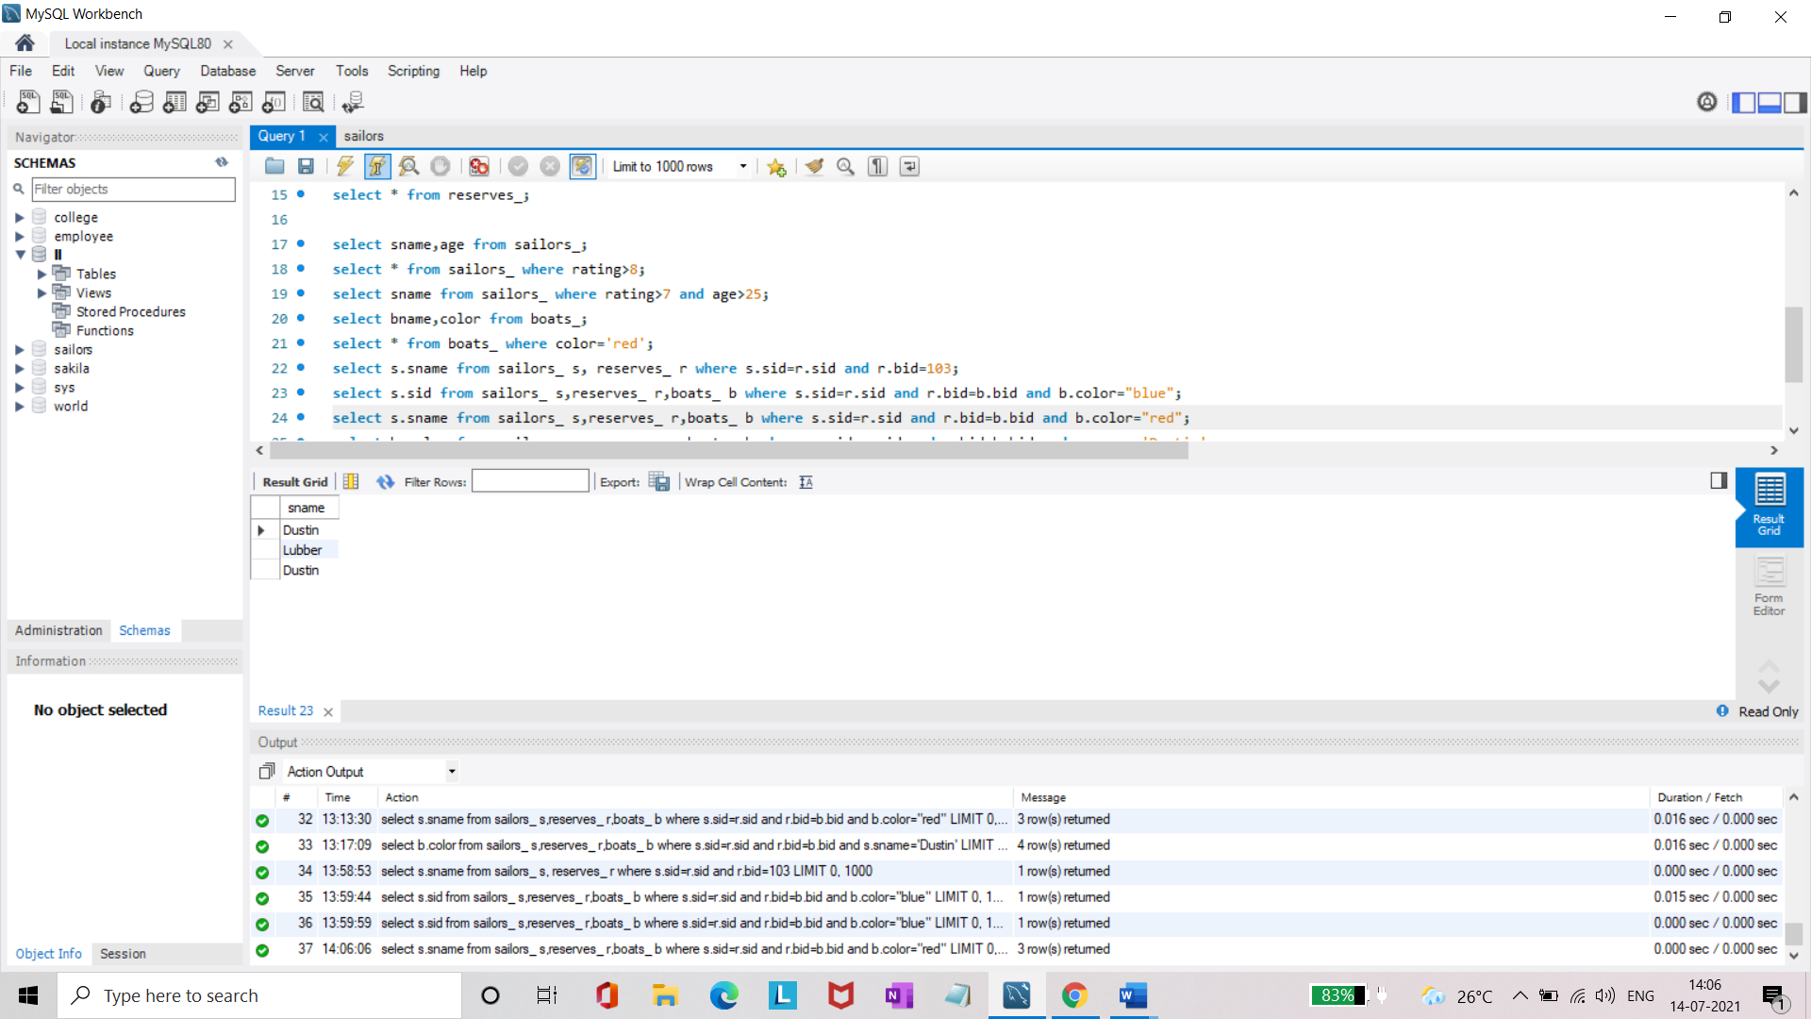

* Find the colours of boats reserved by some name(provide any name in table).

**select b.color from sailors_ s,reserves_ r,boats_ b where s.sid=r.sid and r.bid=b.bid and s.sname='Dustin';**

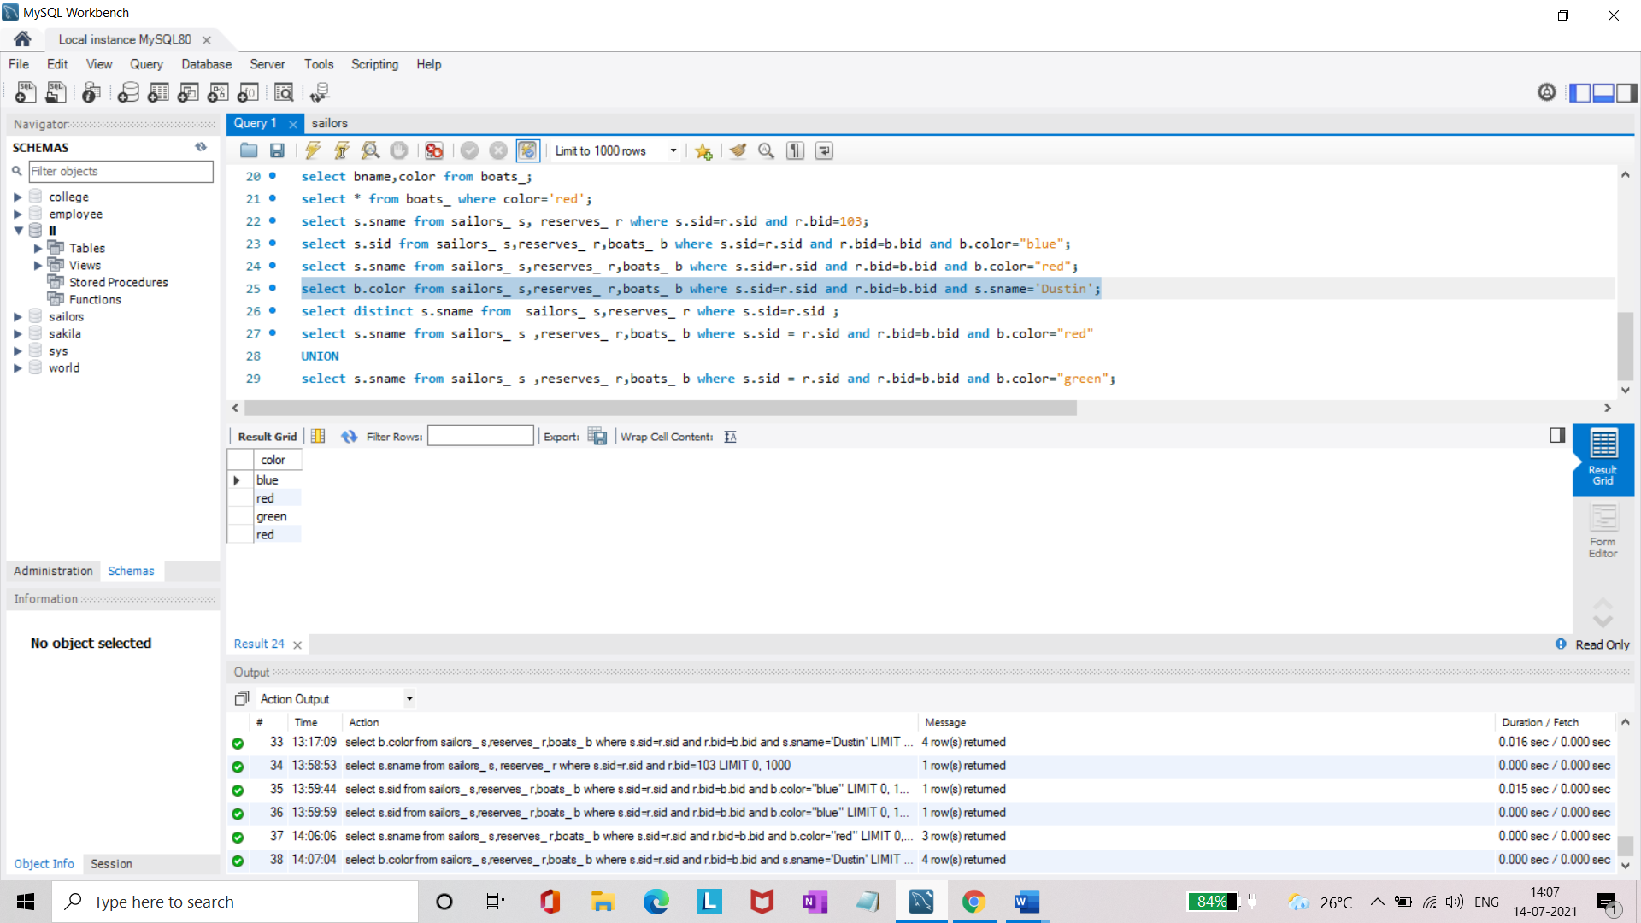

* Find the names of the sailors who have reserved at least one boat.

**select distinct s.sname from sailors_ s,reserves_ r where s.sid=r.sid ;**

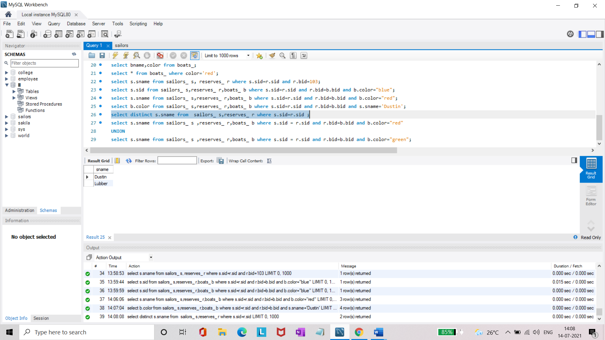

* Find the names of the sailors who have reserved two different boats.

**select distinct S.sname from sailors_ S, reserves_ R1, reserves_ R2 where S.sid=R1.sid and S.sid=R2.sid and R1.bid<>R2.bid;**

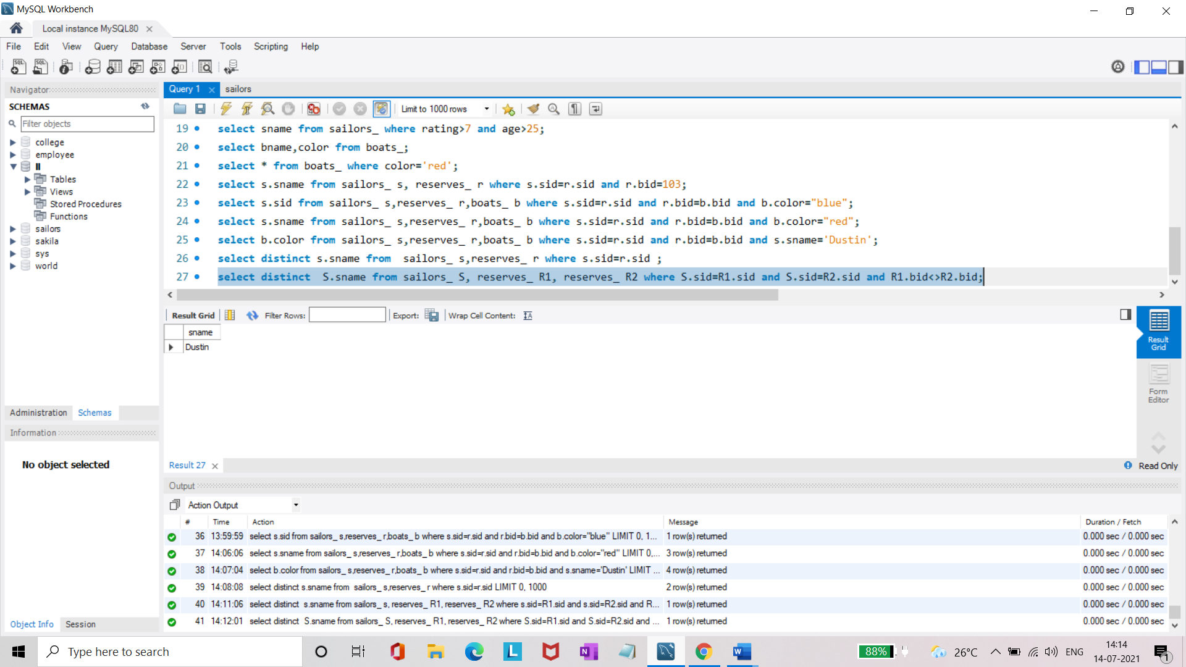

* Find the names of sailors who have reserved a Red or a Green boat.(union)

**select s.sname from sailors_ s ,reserves_ r,boats_ b where s.sid = r.sid and r.bid=b.bid and b.color="red"**

**UNION**

**select s.sname from sailors_ s ,reserves_ r,boats_ b where s.sid = r.sid and r.bid=b.bid and b.color="green";**

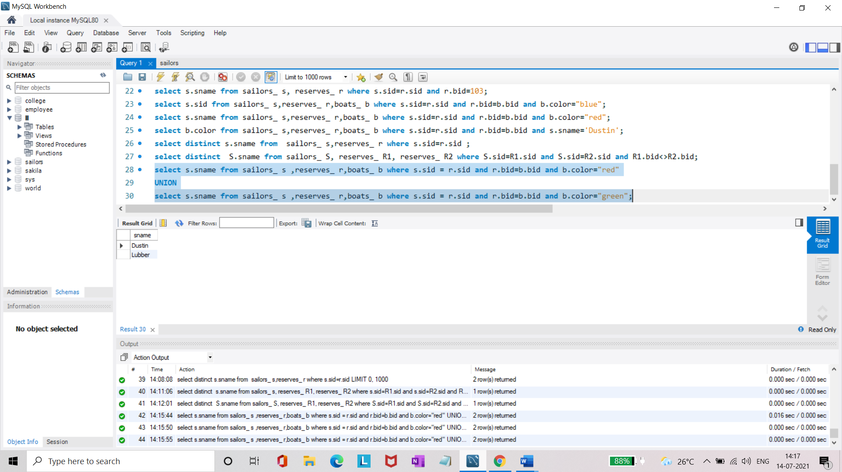

* Find the names of sailors who have reserved both a Red and a Green boat.

**select S.sname from sailors_ S,reserves_ R1,boats_ B1,reserves_ R2,boats_ B2 where S.sid=R1.sid and R1.bid=B1.bid and S.sid=R2.sid and R2.bid=B2.bid and (B1.color='red' and B2.color='green');**

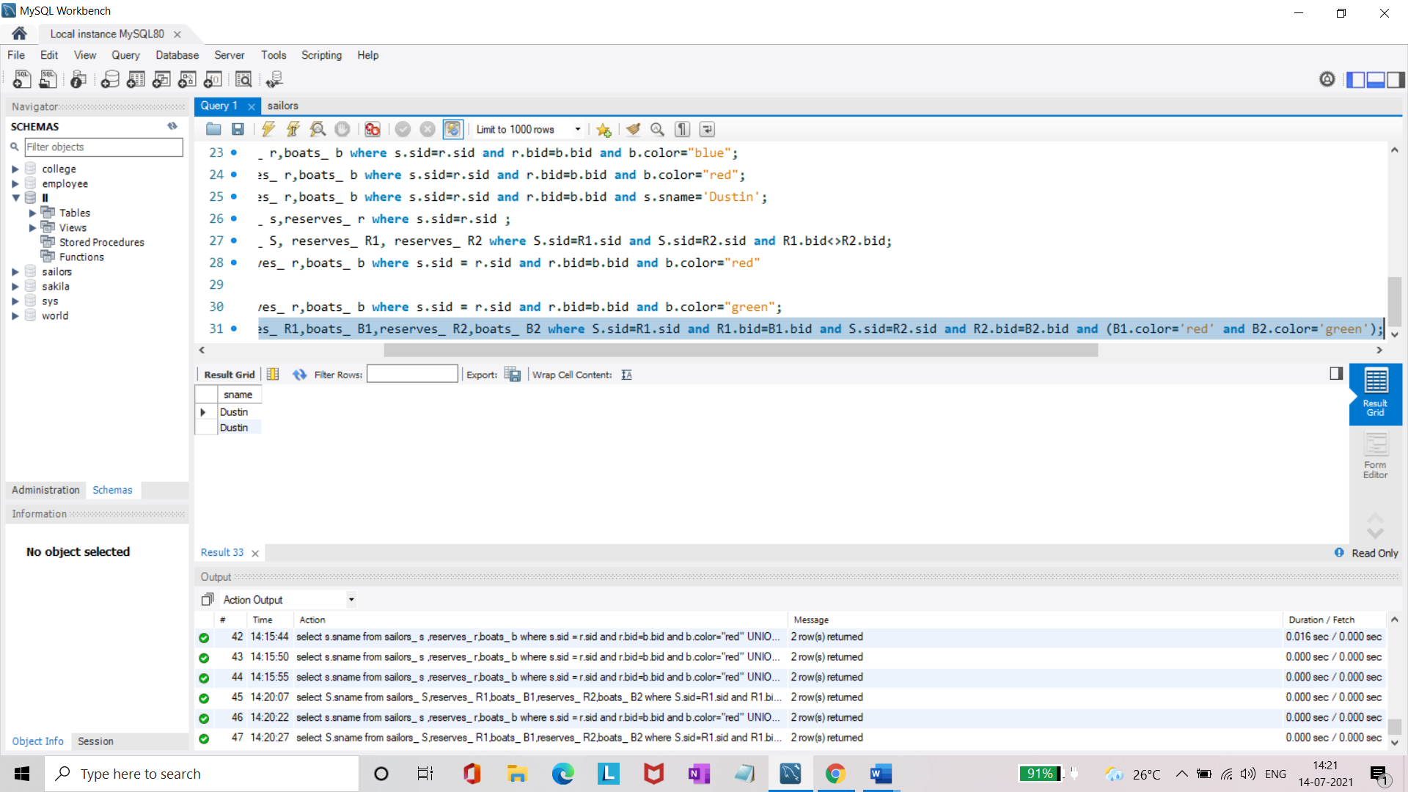

* Find the names of sailors who have reserved boat 103.(nested query)

**select s.sname from sailors_ s where s.sid IN ( SELECT r.sid FROM reserves_ r WHERE r.bid = 103 ) ;**

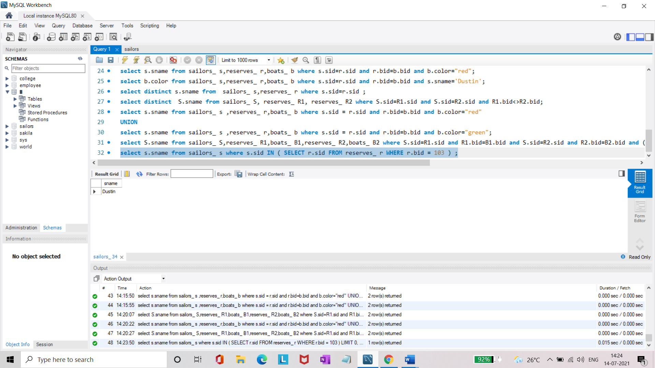

* Find the names of sailors who have reserved red boat.(nq)

**select s.sname from sailors_ s where s.sid IN (select r.sid from reserves_ r where r.bid in (select b.bid from boats_ b where b.color='red'));**

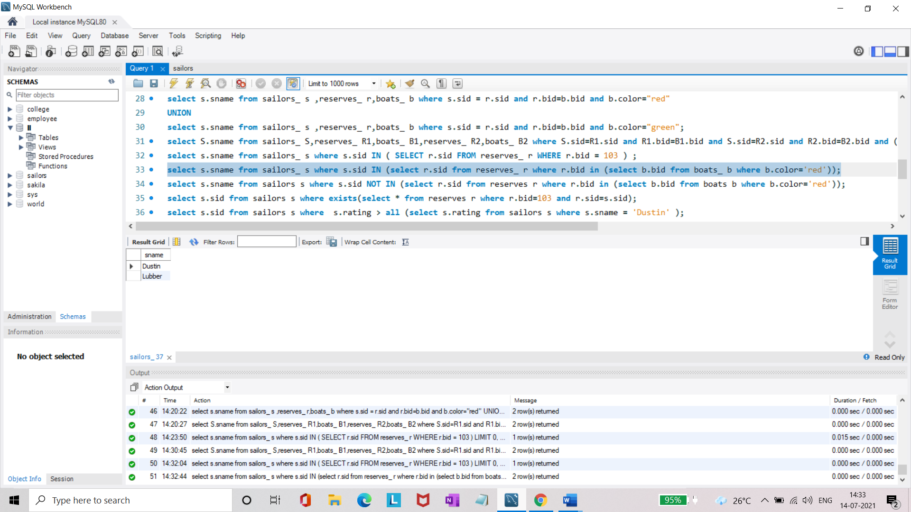

* Find the names of sailors who have not reserved red boat.(nq)

**select s.sname from sailors_ s where s.sid NOT IN (select r.sid from reserves_ r where r.bid in (select b.bid from boats_ b where b.color='red'));**

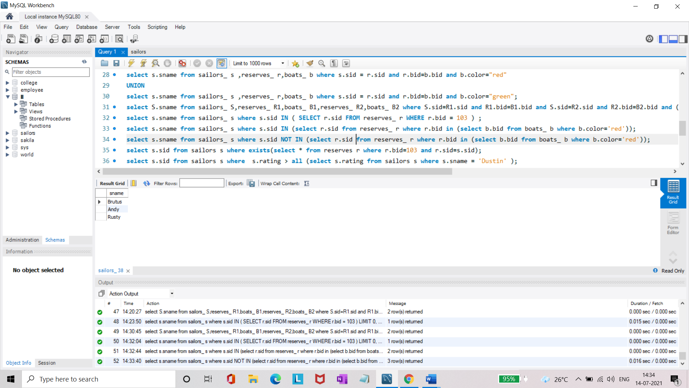

* Find the names of sailors who have reserved boat number 103.(exists)

**select s.sid from sailors_ s where exists(select * from reserves_ r where r.bid=103 and r.sid=s.sid);**

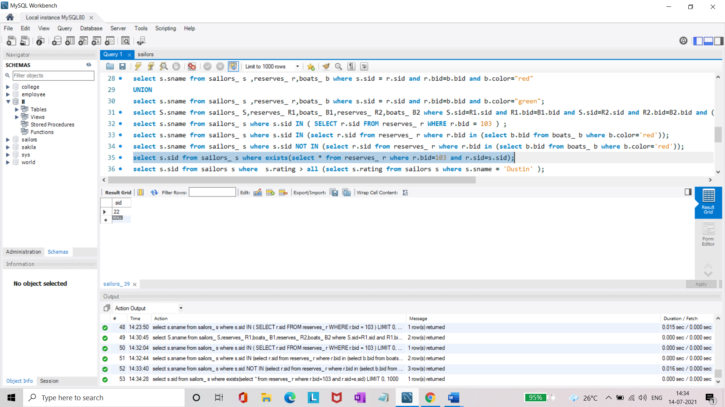

* Find sailors whose rating is better than some sailors called name.

**select s.sid from sailors_ s where s.rating > ANY (select s.rating from sailors_ s where s.sname = 'Dustin' );**

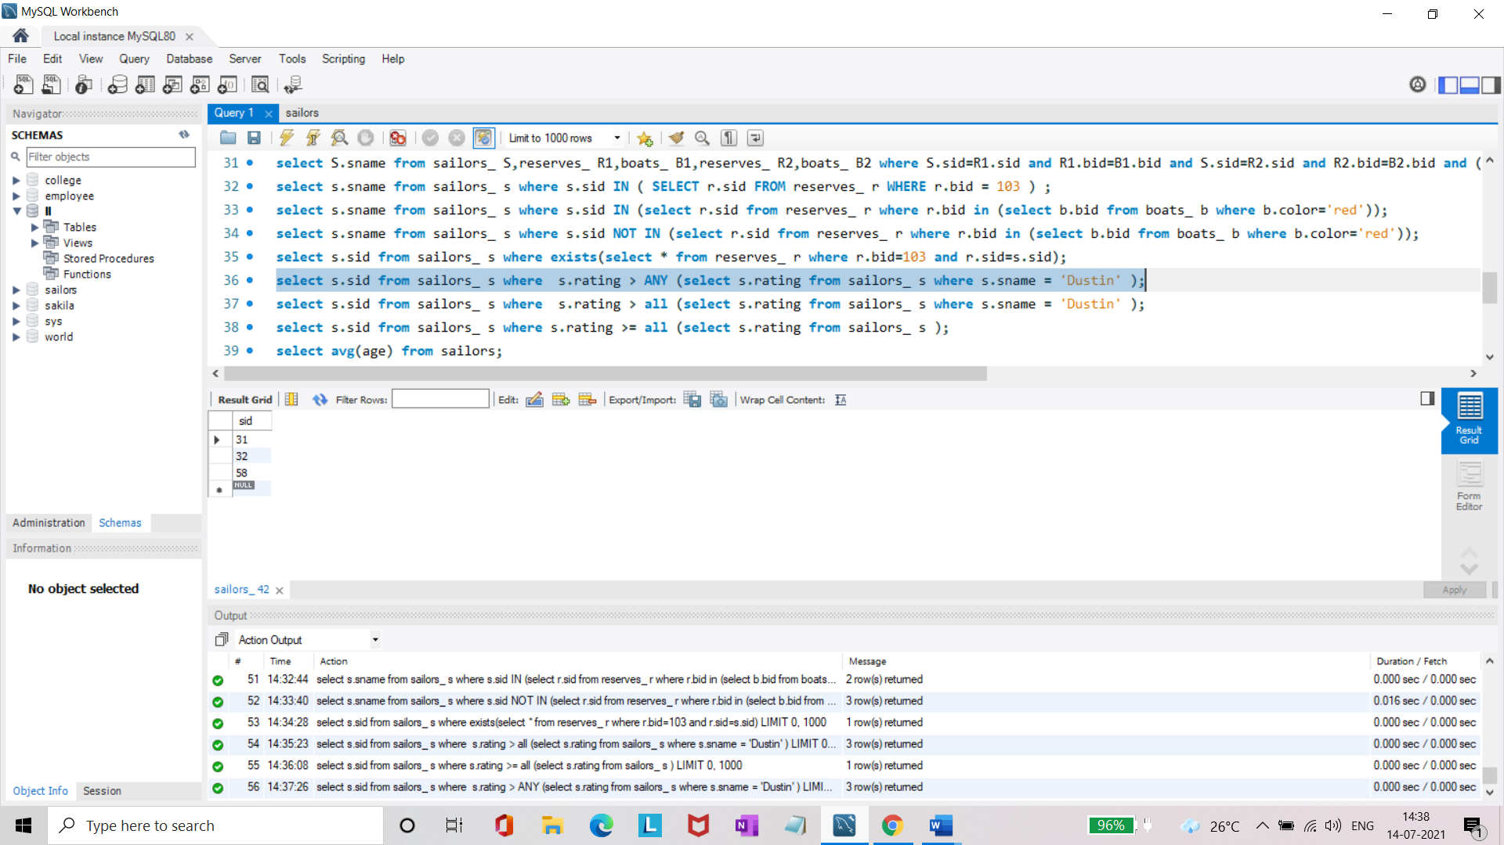

* Find sailors whose rating is better than every sailor' called name.

**select s.sid from sailors_ s where s.rating > all (select s.rating from sailors_ s where s.sname = 'Dustin' );**

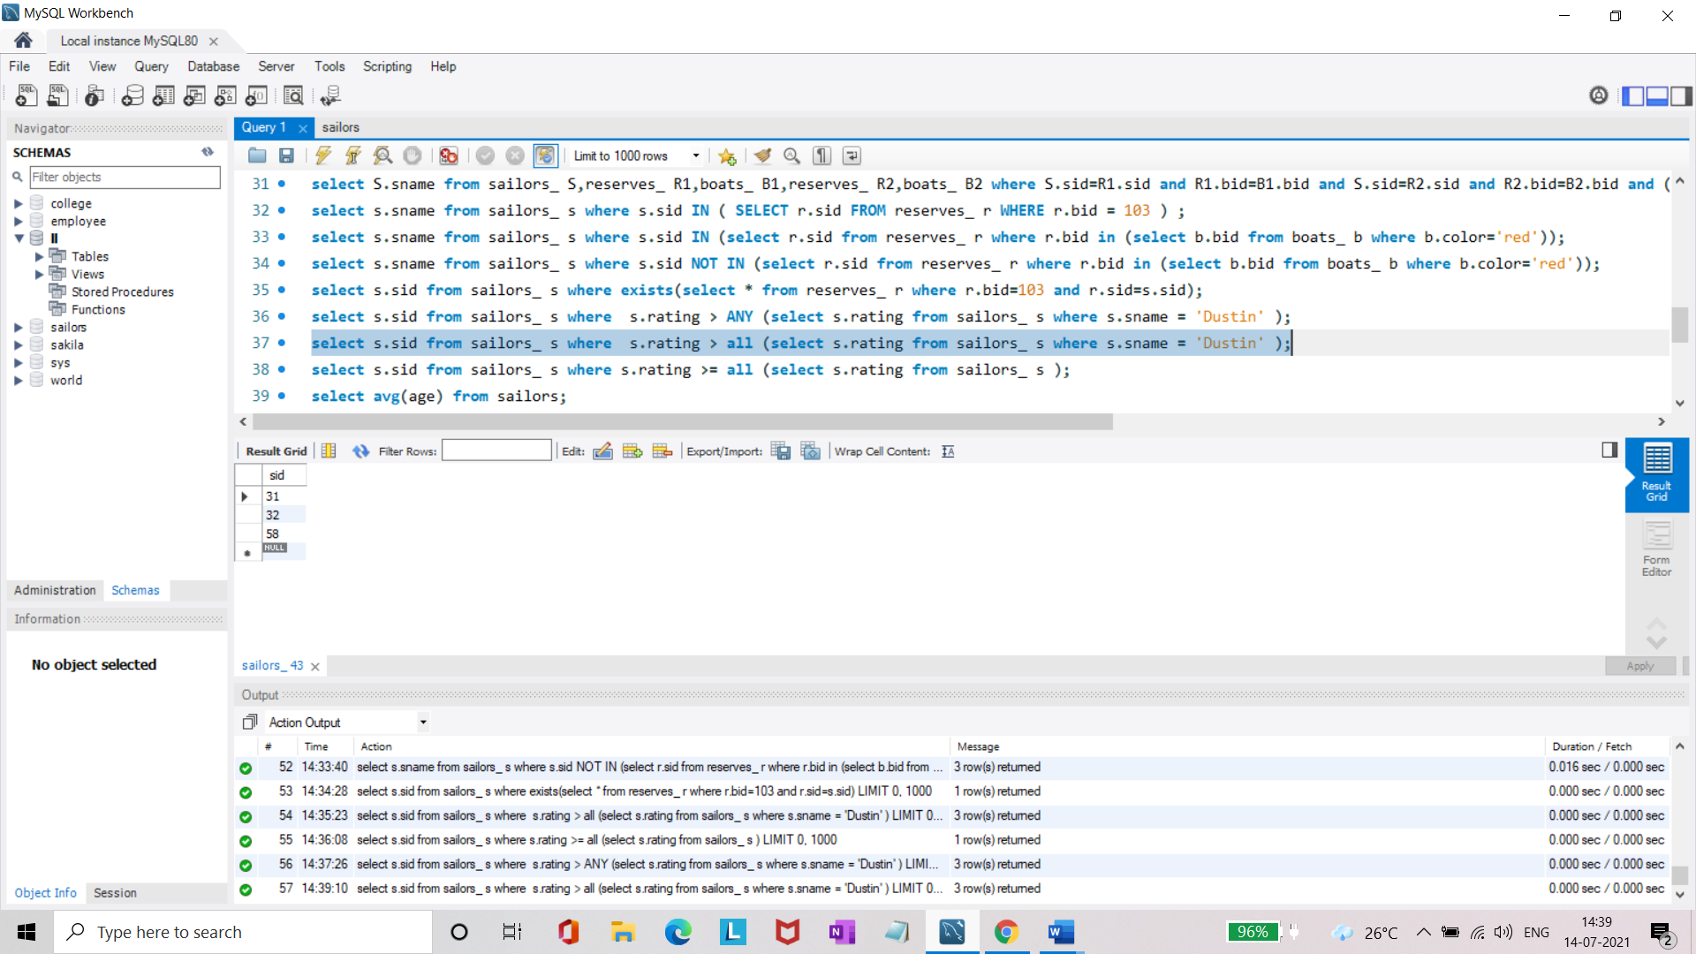

* Find the sailors with highest rating.

**select s.sid from sailors_ s where s.rating >= all (select s.rating from sailors_ s );**

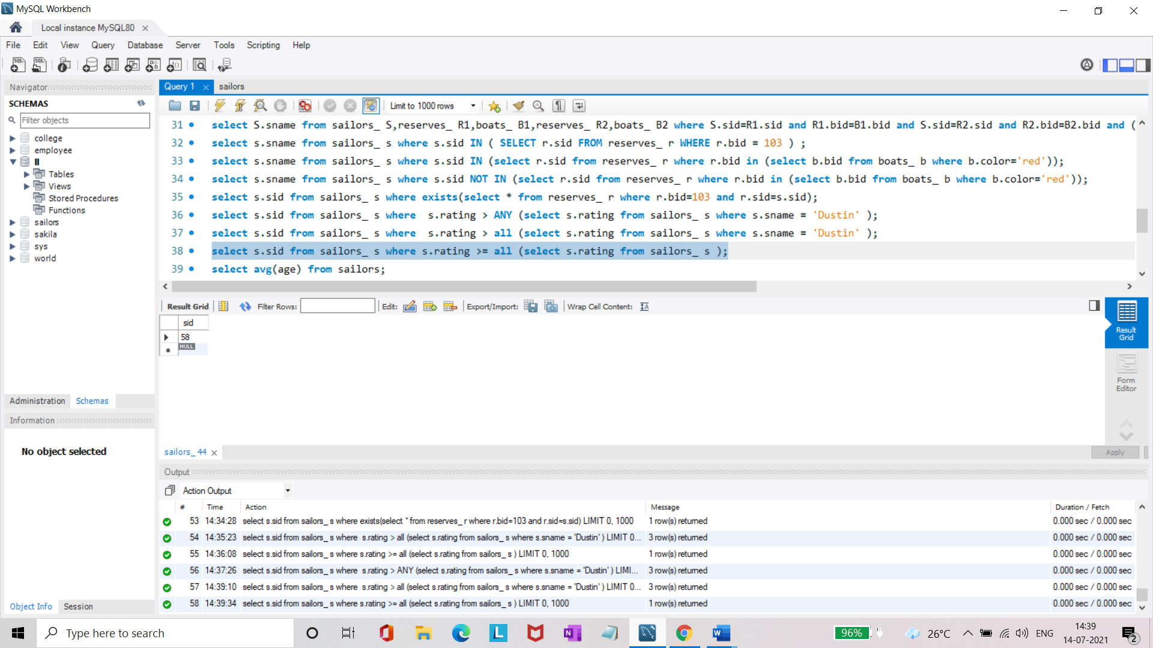

* Find the average age of all sailors.

**select avg(age) from sailors_;**

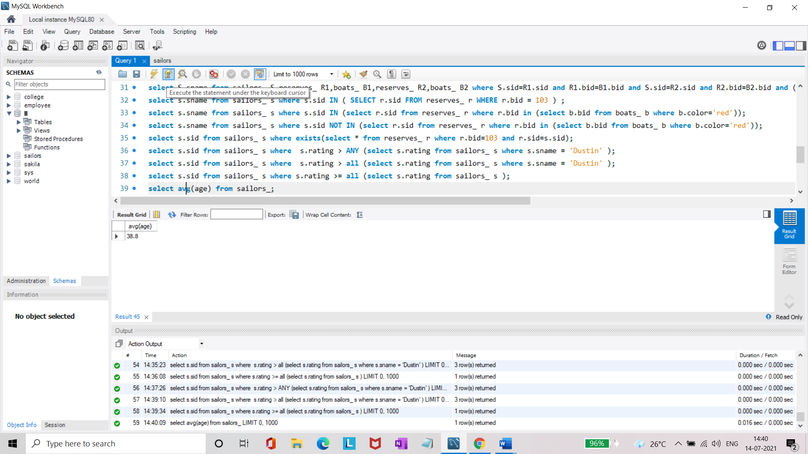

* Find the average age of sailors with a rating of 10.

**select avg(s.age) from sailors_ s where s.rating = 10;**

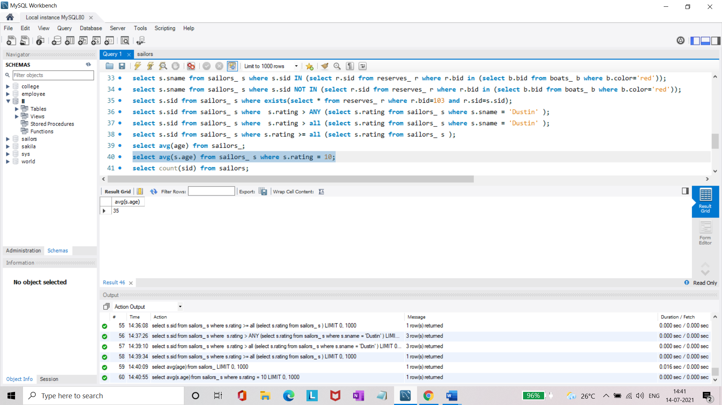

* Count the number of sailors.

**select count(sid) from sailors_;**

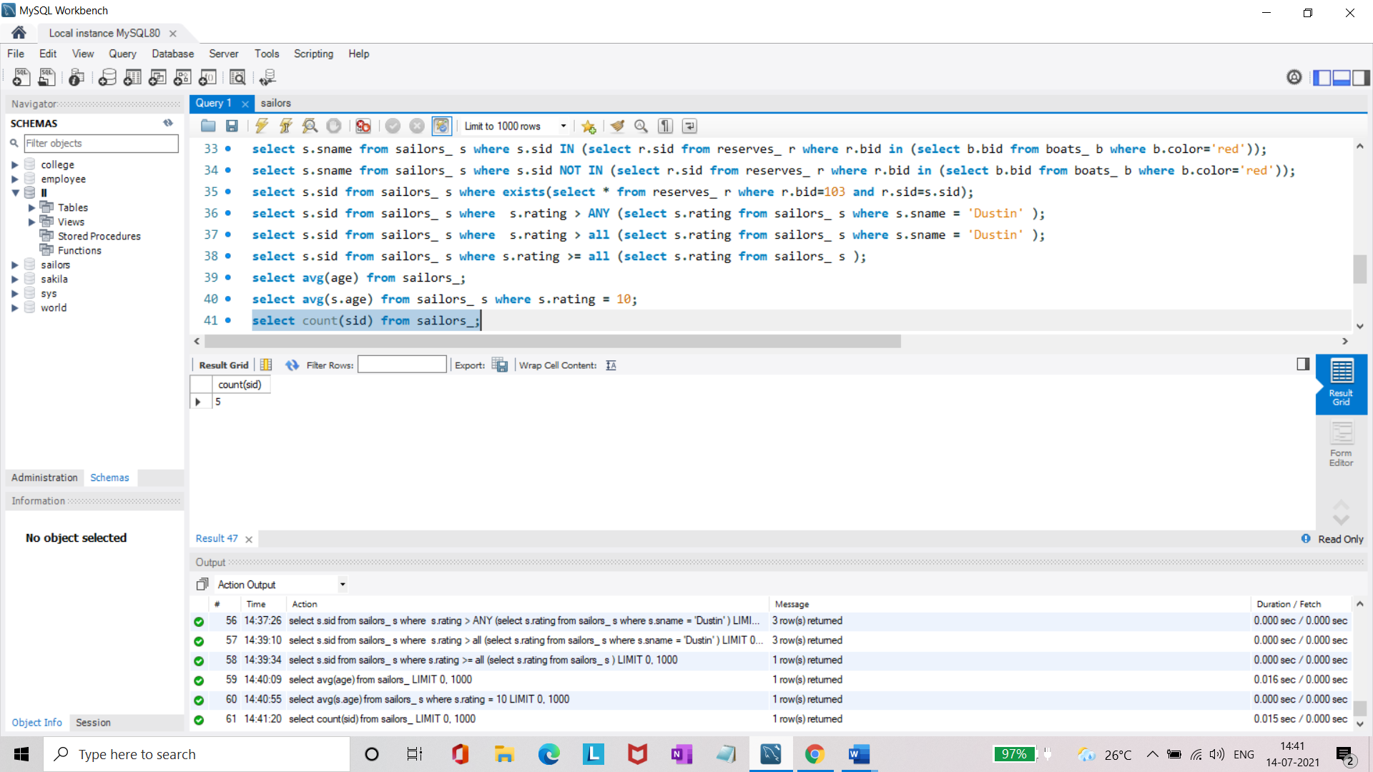

* Count the number of different sailor ratings.

**select count(distinct rating) from sailors_;**

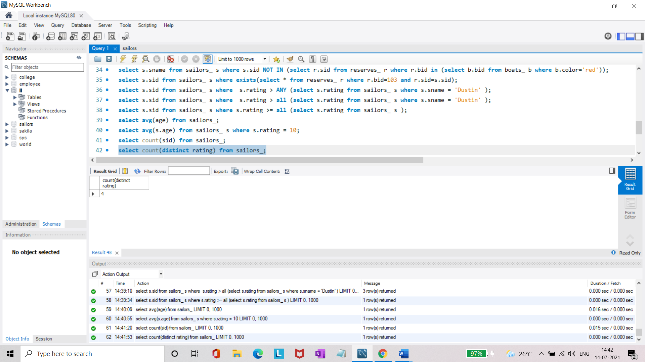

* Find the name and age of the oldest sailor.

**select s.sname,s.age from sailors_ s where s.age= (select max(s.age) from sailors_ s);**

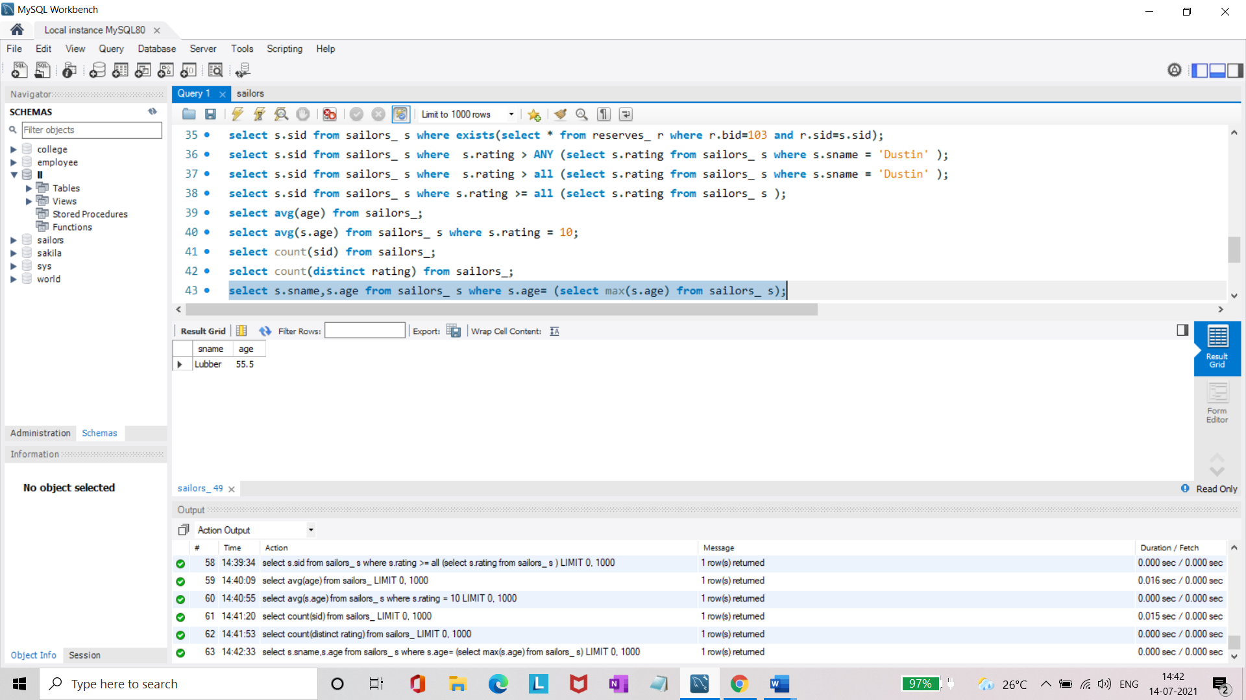

* Find the names of the sailors who are older than the oldest sailor with a rating of 10.

**select s.sname from sailors_ s where s.age>all(select max(s.age) from sailors_ s where s.rating=10 );**

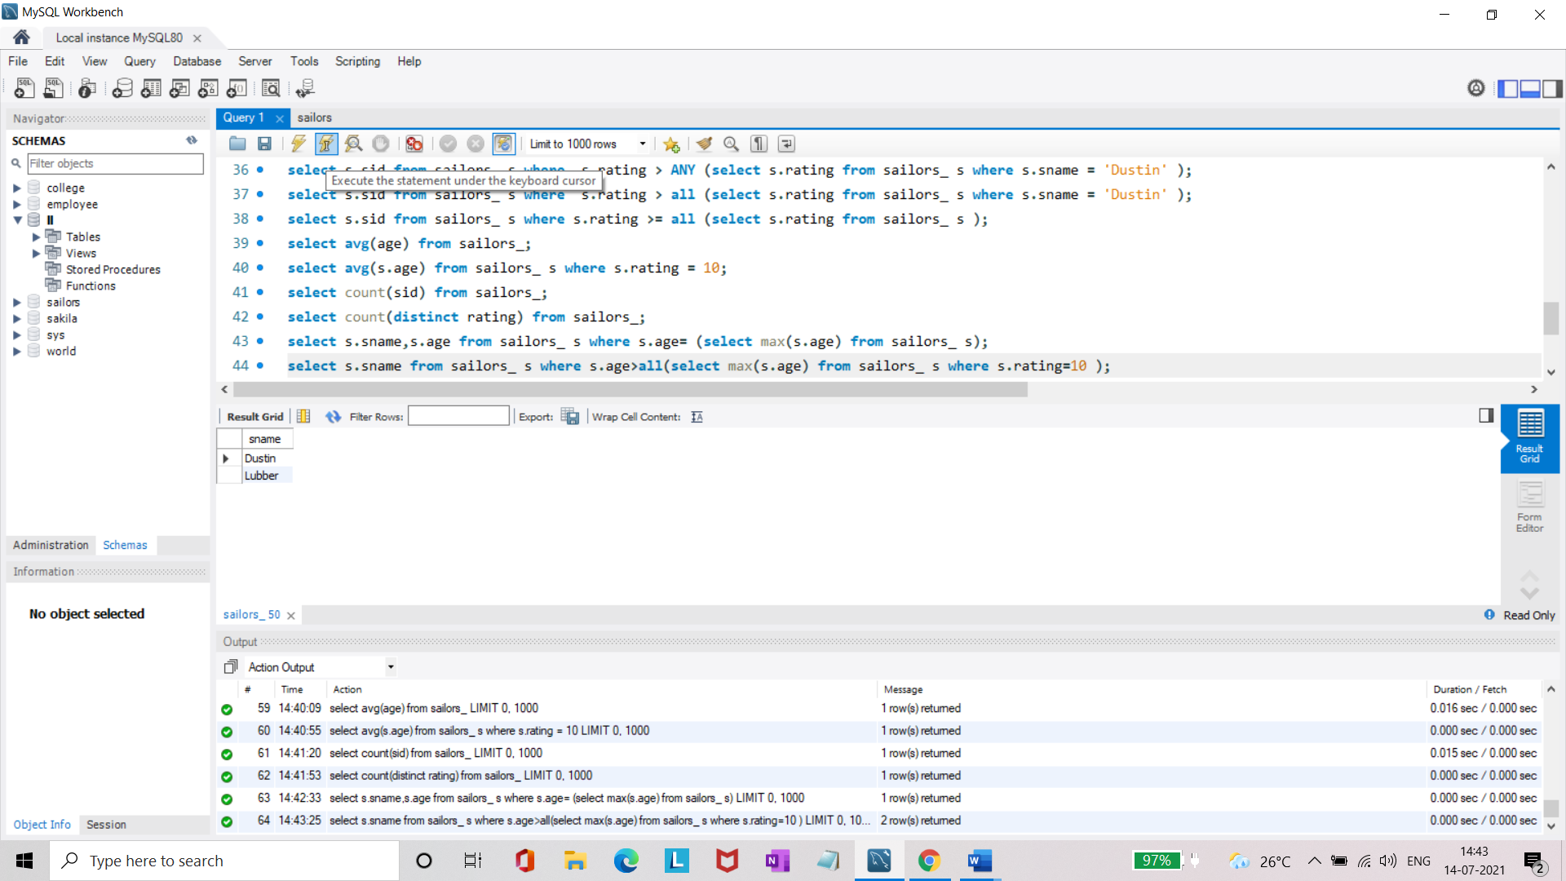

* Find the age of youngest sailor for each rating level.

**select s.rating, min(s.age) from sailors_ s group by s.rating;**

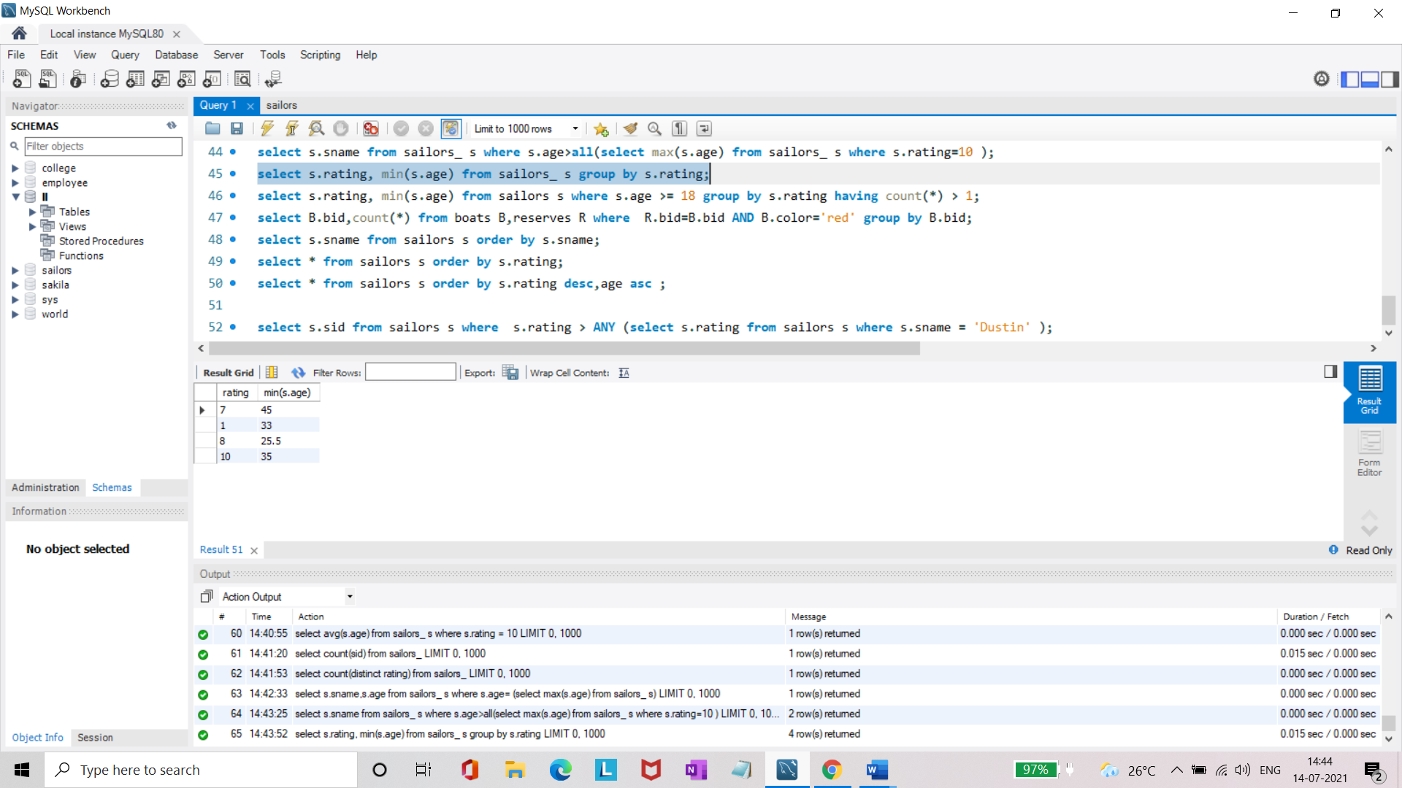

* Find the age of the youngest sailor who is eligible to vote (i.e., is at least 18 years old) for each rating level with at least two such sailors.

**select s.rating, min(s.age) from sailors_ s where s.age >= 18 group by s.rating having count(*) > 1;**

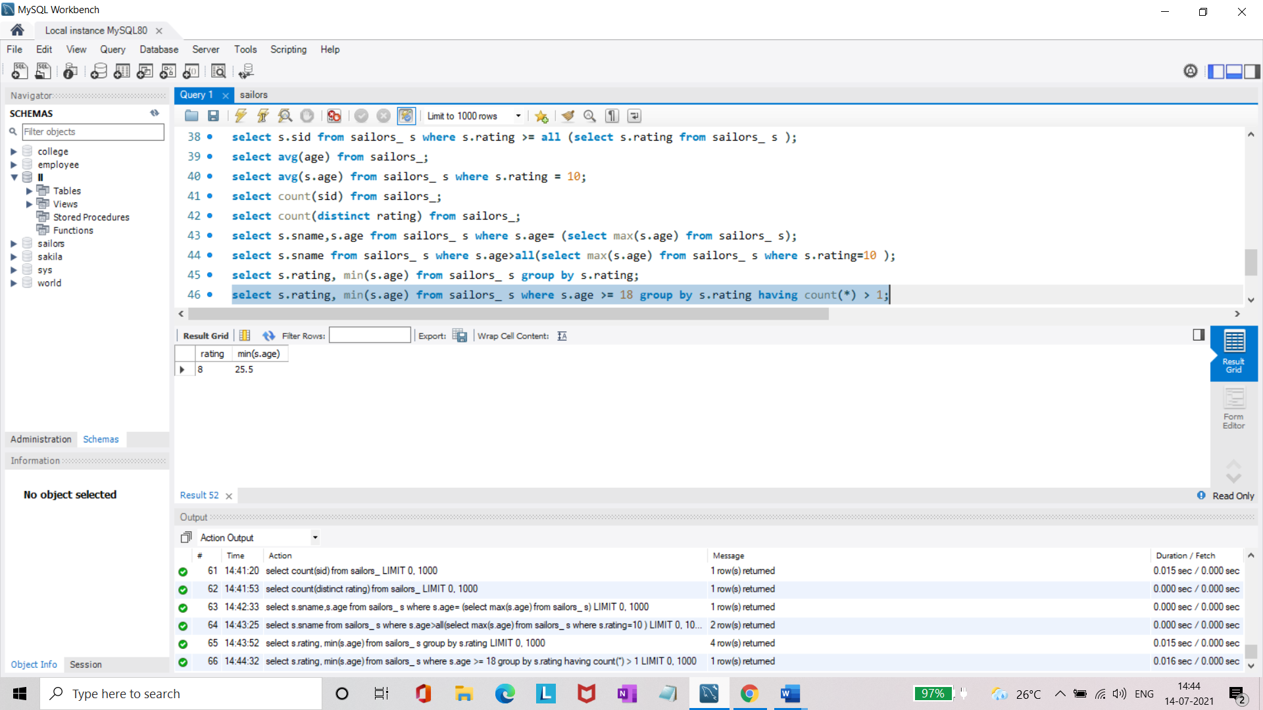

* For each red boat, find the number of reservations for this boat.

**select B.bid,count(*) from boats_ B,reserves_ R where R.bid=B.bid AND B.color='red' group by B.bid;**

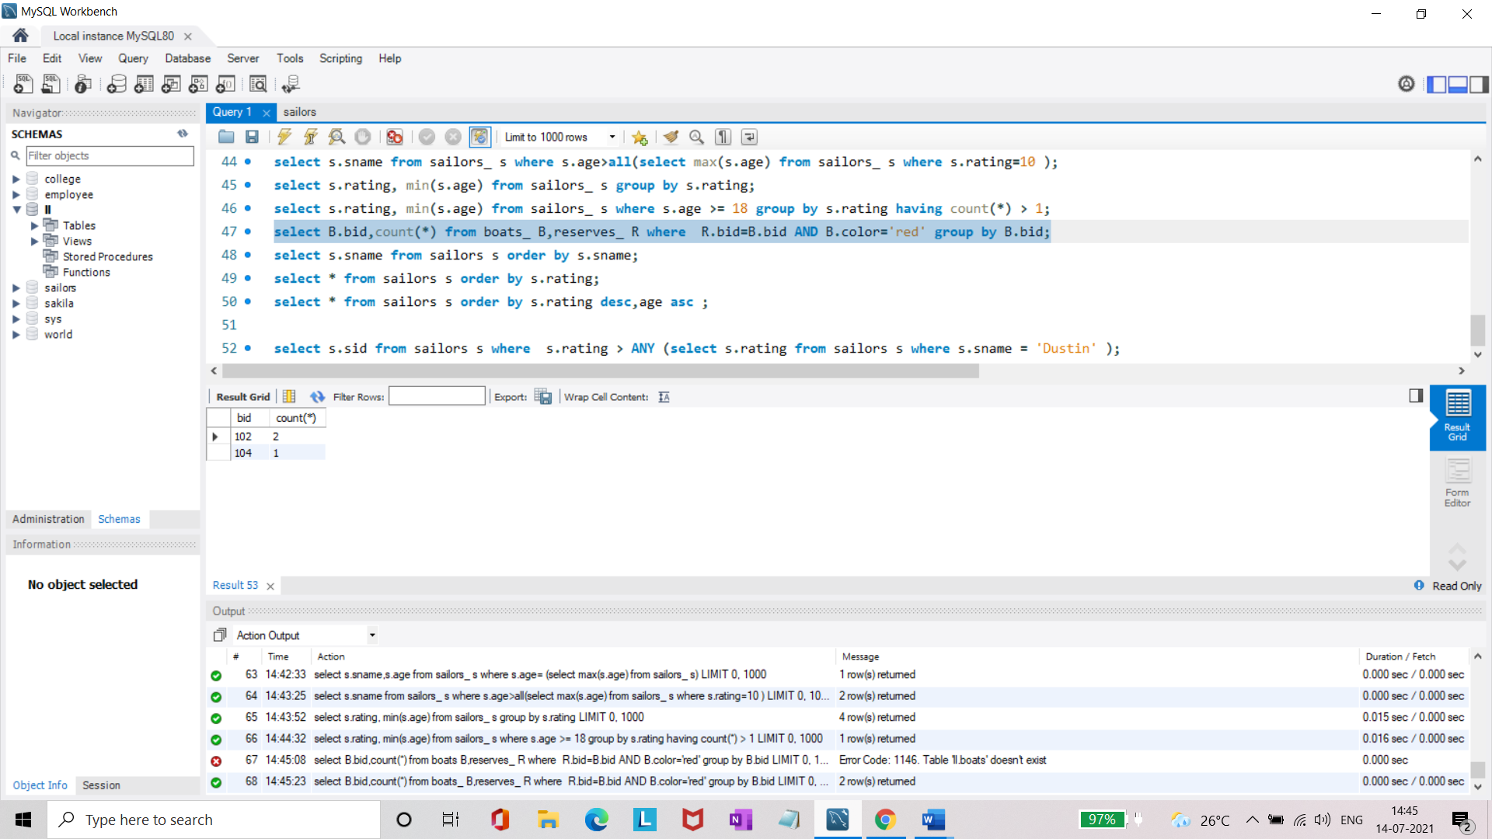

* Find all sailors name according to names.

**select s.sname from sailors_ s order by s.sname;**

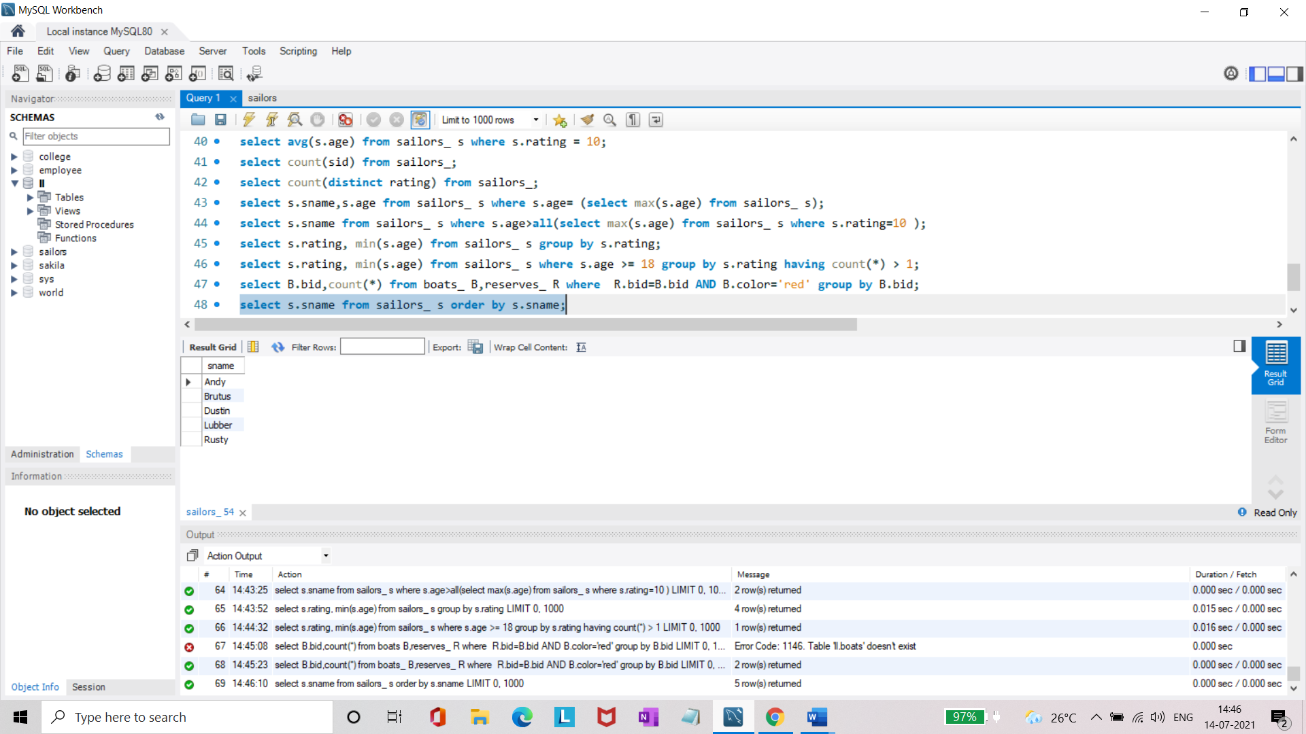

* Find all sailors details according to rating.

**select * from sailors_ s order by s.rating;**

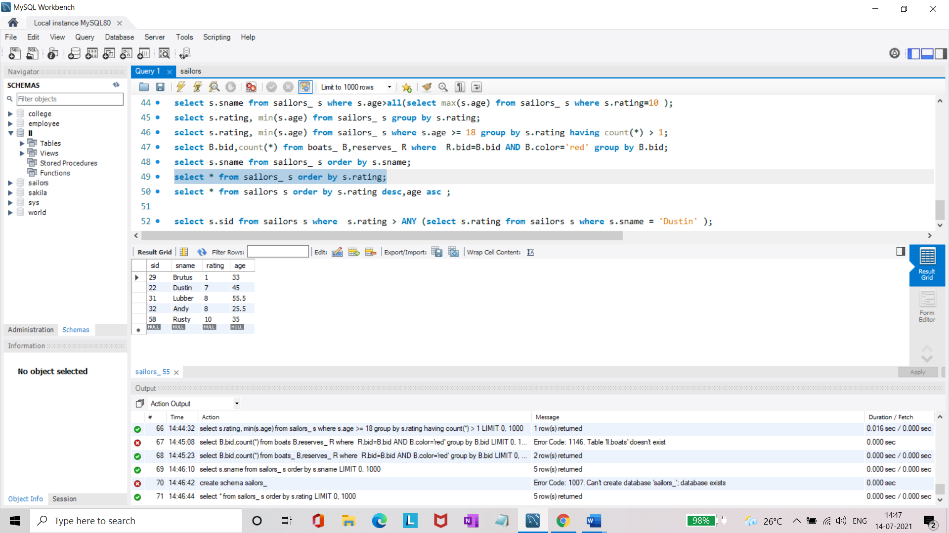

* Find all sailors details according to rating(highest first) if ratings are same then according to age(youngest first).

**select * from sailors_ s order by s.rating desc,age asc ;**

